**Basic Linux Commands Assignments**

**Assignment-1**

**Connect and disconnect with login Access**

* What happens when you login a non-existent users or username?
  + Provide Screenshot and what you understand, explain in short brief?

**Ans** 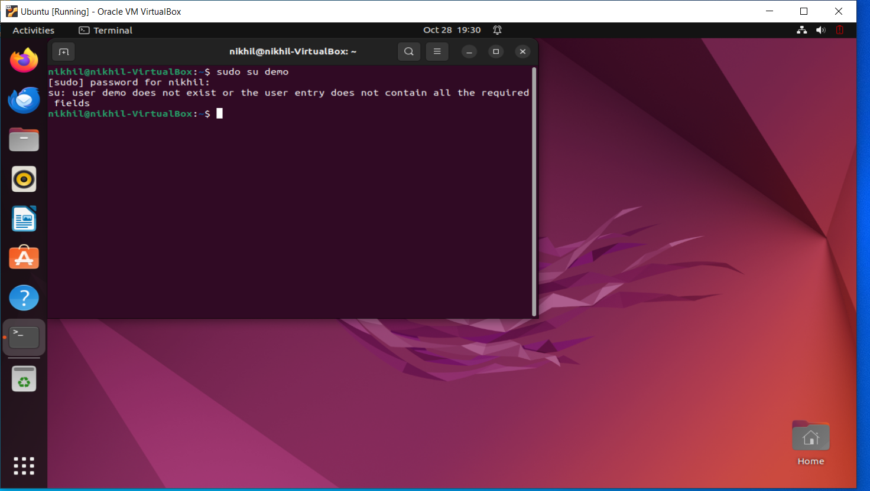

User does not exist in /etc/passwd or user does not have necessary's requirement. It’s a user which doesn’t have login permission.

**Assignment-2**

**Password changing**

* Login into your account and then change password?
  + Change your password into **IneuR0n#42** and hit the **Enter** key
    - Explain what happen and give screenshot?
  + Try again to change password but use like password ***1234*** or ***abcd***
    - Explain what happen and give screenshot?
  + Try again to change password but now don’t use any password just hit **Enter** key

Explain what happen and give screenshot?

Ans 2 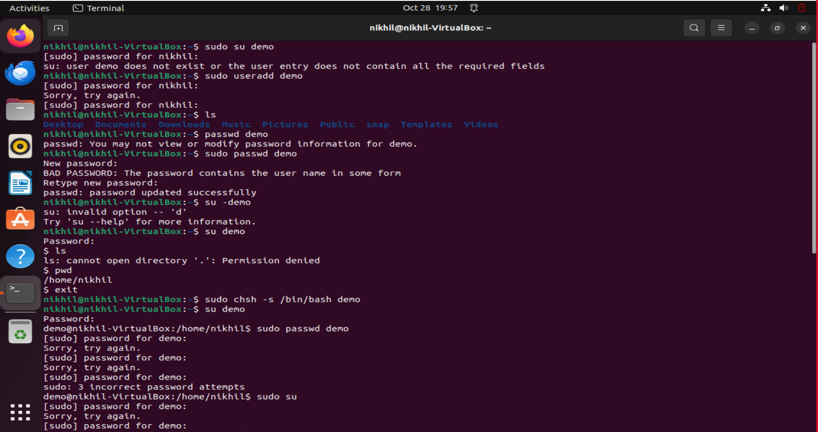

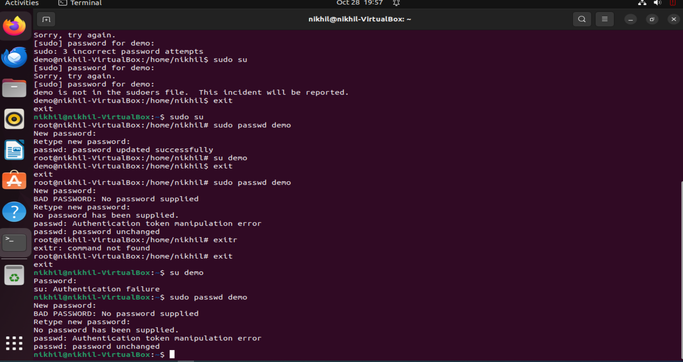

While changing the password it’s changed but we have also configure user on bash shell as you see

On without use password and hit enter it give error like authentication token manipulation error as you on screenshot

**Assignment-3**

**Working with Directories**

* Enter the command **cd /** and then **ls** and then hit **Enter** key
  + Take screenshot and explain what output we got?
* Enter the command now **cd /home** and then hit **Enter** key
  + Do **ls,** provide screenshot and explain what is **/home** directory used for?
* Enter **cd ..** and hit **Enter** key [ *Note: here we have space after cd then use double dot*]
  + Check what happen and give screenshot?
* Now enter **cd /var/www/html** and then type **cd** and hit **Enter** key
  + Explain what happen and give screenshot?
* Now type **cd /root** and then hit **Enter** key
  + Do **ls,** check any output we have on screen if yes then take screenshot?

ANS 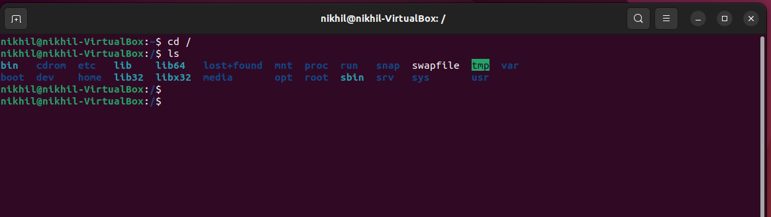

/ This represent the root directory after ls cmd we get like directories, files



In Linux, the **/home** directory is typically used to store user home directories. Each user on a Linux system is assigned a home directory within the **/home** directory, and this is where their personal files and settings are stored



**Cd..**in Linux is a command used to change the current working directory to its parent directory. The **cd** stands for "change directory," and.. Represents the parent directory.

Cd /var/www/html

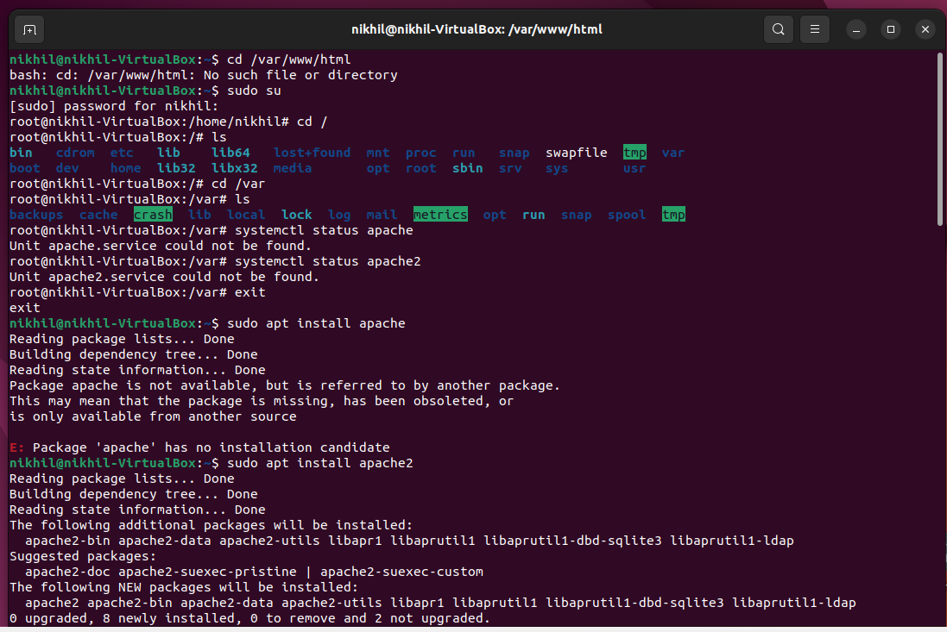

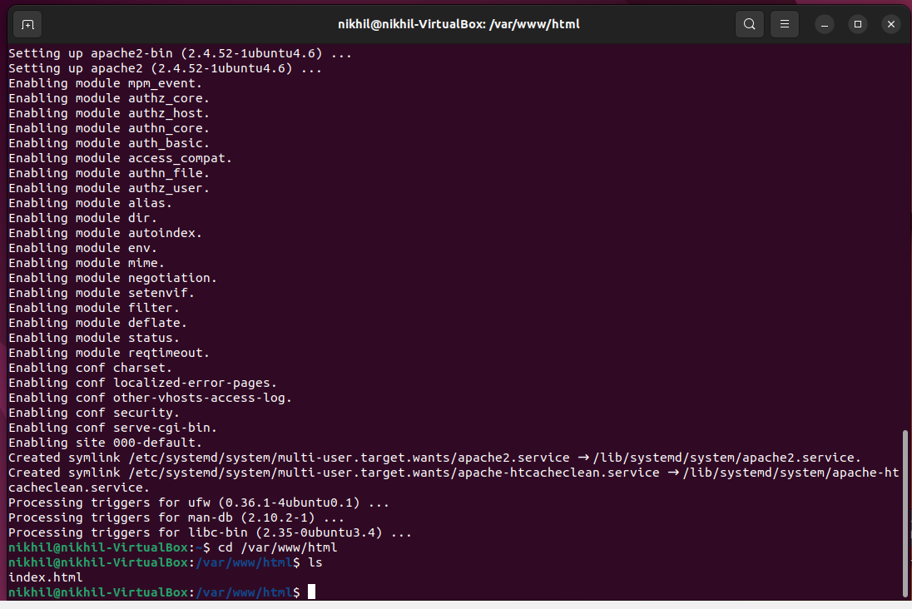

Cd /root

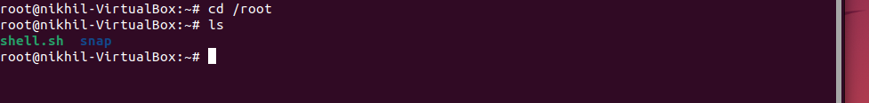

Assignment-4

**Working with File Listing**

* Go to **cd /etc** and type **ls**
  + Take screenshot and explain what files you have seeing?
  + Take screenshot and explain what different output you found compare to previous command you used?
* Then type **ls -al** and hit **Enter** key
  + Take screenshot and explain what new file or directory you found?
* Then use **ls -i** and hit **Enter** key
  + Now see what different output its shows and take screenshot?
* Then use **ls –help** and see other options about **ls** command

Explore it and try with other attribute we can use with **ls** comman

Ans 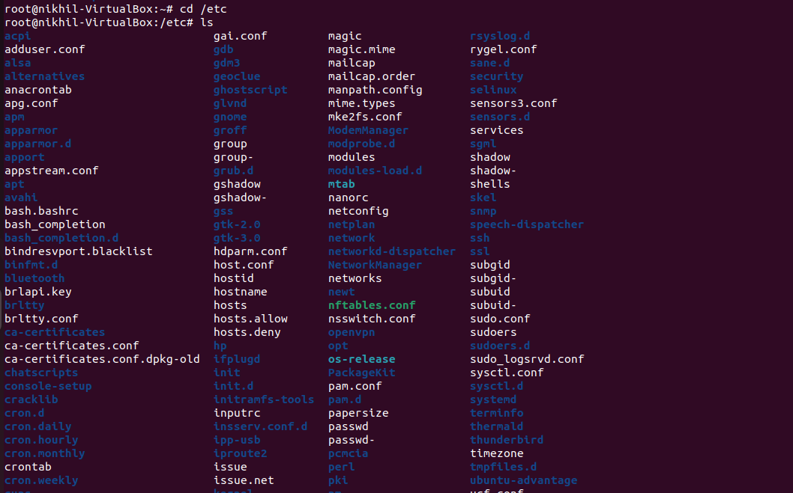

ls –al

**Ans. When we are using ls –al and ls –I both are different**

**In ls –al we are getting files with permission along with size but when we are using ls –I we are getting inode number represent values for every files and directory**

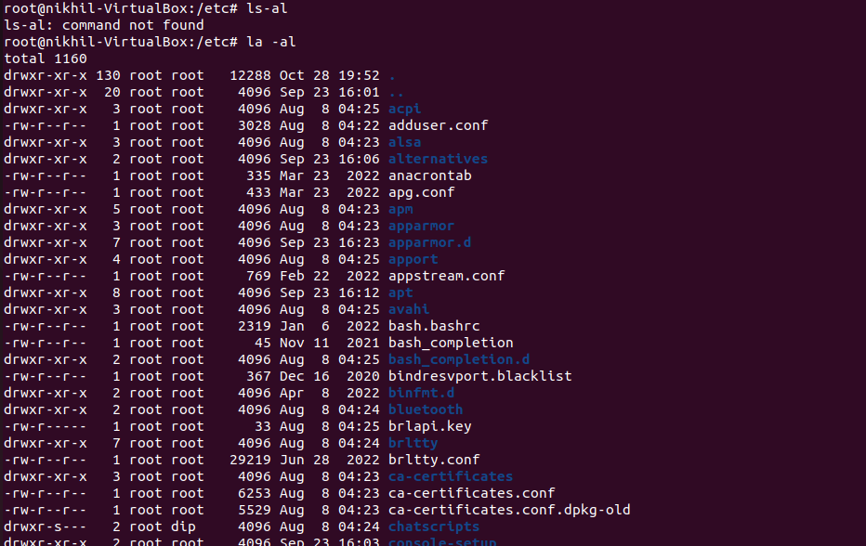

Ls -i

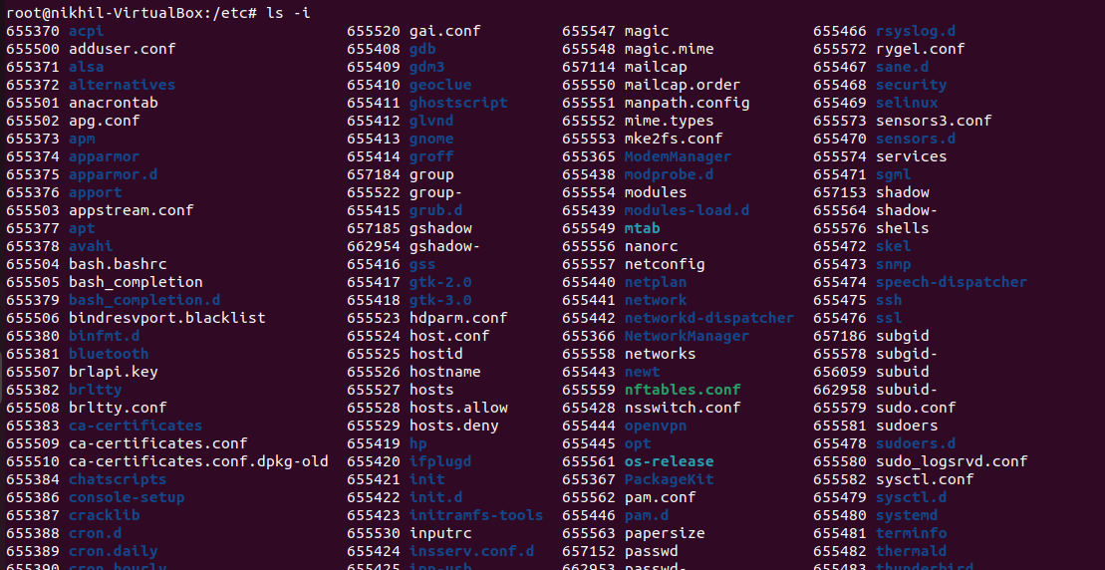

ls --help

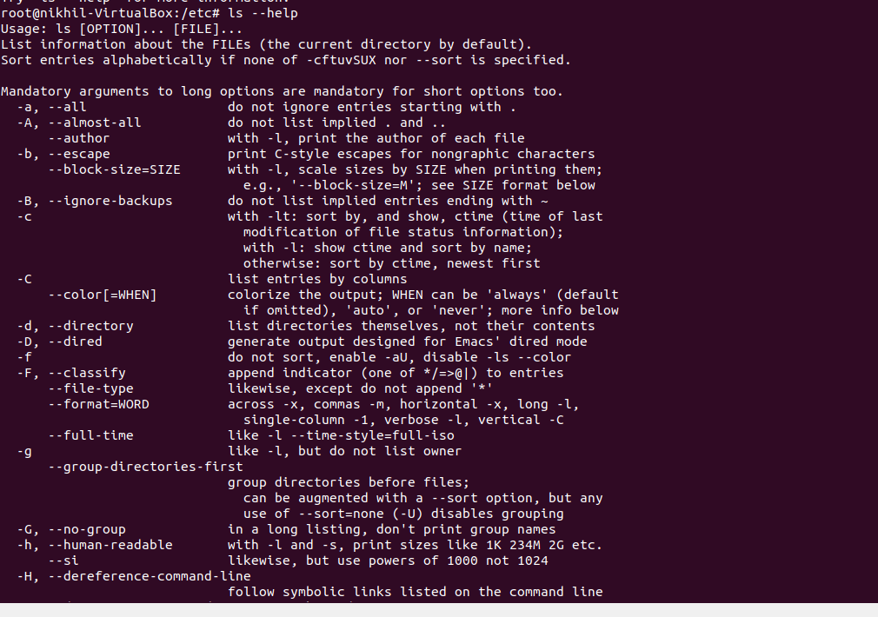

**Assignment-5**

**Know where you are and where you working**

*Here we use* ***pwd, cd and ls*** *as combine task to understand where you working on terminal and how you can switch from one directory to another one.*

* Open terminal after restart the linux
  + Check which location you working, type **pwd** and take screenshot
* Now use **cd /var** and hit **Enter** key
  + Do **ls,** and see what output comes, give screenshot?
* Do explore other help options of each command to learn more other things we can do with these commands

Ans 